Flowers to say "Get Well Soon"

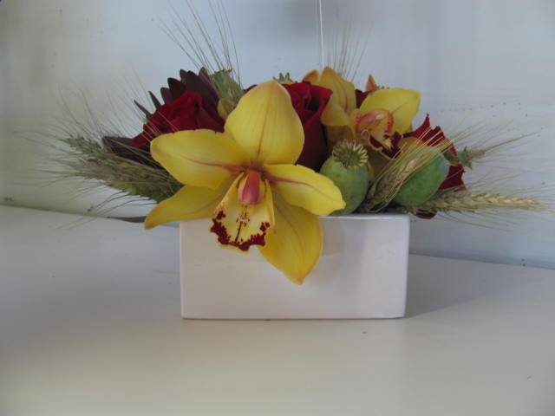



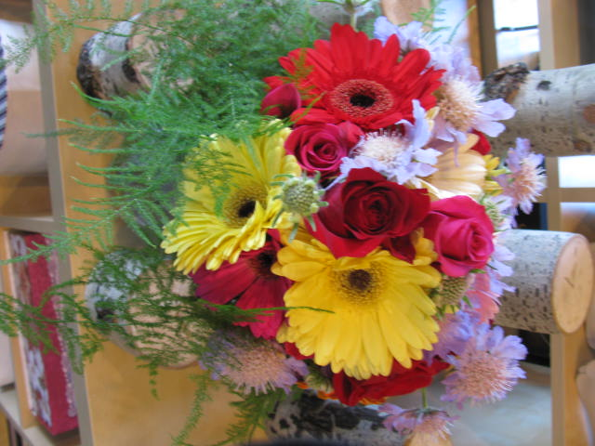



$100.00 Exotic

$50.00 Arrangement

$30.00 Hand-tied Bouquet

Get Well flowers from **Stemz Florist & Treasures** are a great way to let someone who is ill or feeling blue know that you're thinking of them. A compact arrangement of flowers is a terrific way to brighten up a hospital room and ease the loneliness of recovering at home.

If you are sending to a hospital, **Stemz Florist & Treasures** will help you choose the most appropriate flowers, making sure the arrangement isn't too fragrant or overpowering. Flower plants will most certainly be an appreciated *Get Well* gift. More and more, researchers are saying that the presence of flowers triggers happy emotions and heightens strong, positive feelings of well-being.

**Also, remember to send flowers to the shut-ins as well!**